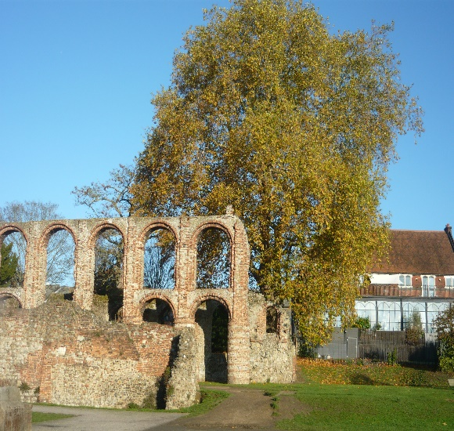
St Botolph’s Church
Colchester
March 2022 Newsletter

May we find strength in prayer to get us through difficult times. And may we be inspired to share hope & love with others.

Dear Friends,
As we watch the unfolding events in the Ukraine with dismay let us turn to God’s Word to lead us through the coming days & weeks.
PSALM 23 vs 4 : even though I walk through the valley of the shadow of death, I will fear no evil, for you are with me; your rod & your staff they comfort me.
If there are opportunities to help the people losing their homes, their livelihoods & family we pray that we will find a way to respond.
As we journey through Lent towards Good Friday & Easter Day, we are holding 4 Lent Meetings led by Colin Nicholson entitled LIVING HIS WAY. These will be on Fridays March 18th & 25th, April 1st & 8th at 10.30am at St. Botolphs in the Hall. Friends from Castle Methodist will be joining us.
On Sunday 6 March we were very pleased to welcome into St. Botolphs Ben & Steph Mills with baby Emily & their family & friends to share in her Baptism, it was a very happy & joyful service.
On Easter Saturday there will be the wedding at St. Botolphs Church, the first for many months.
We continue to pray for all our friends who are unable to be with us in church for whatever reason. We pray for healing & strength to enable them to be comfortable in their homes or wherever they may be.
NEWS FROM PCC MEETING. We are looking at the prospect of resuming Coffee after the service, possibly on the 1st Sunday of the month. If you have any comments on this please speak to David or Gill.
The Royal British Legion contacted St. Botolphs to ask if we would accept the Laying up of their standard in our church. The PCC were 100% in favour & are in the process of requesting a faculty from the Diocese to do this.

Services for the coming weeks are:
Sunday 13 March Holy Communion Michael Fox Sunday 20 March Morning Service Clive Joyce Sunday 27 March Holy Communion Mothering Sunday Sunday 3 April Morning Service Paul Norrington Sunday 10 April Holy Communion Michael Fox Palm Sunday Friday 15 April Good Friday with Castle Methodist at St. Botolphs. At 10.30am
Following the completion of repairs & re-decoration to the Chancel, Concerts have resumed.
March 12th St. Botolph’s Music Society March 19th Colchester Choral Society March 26 CSO April 9 Essex Youth Orchestra April 30 Lexden Choral Society
Mission Group
COLIN gillandcolin@gcn14.plus.com 01206 577905 CHRIS chris.kidd-stanton@talktalk.net 01206 549374 NICKY phllnick@aol.com 01206 549145

Excerpt from the Prayer for Ukraine:
We pray for people of Ukraine today. We pray for peace & the laying down of weapons. We pray for all those in fear of tomorrow that your spirit of comfort would draw near to them. Above all, we pray for your precious children, at risk & in fear. We pray in the name of Jesus, Prince of peace, Amen

